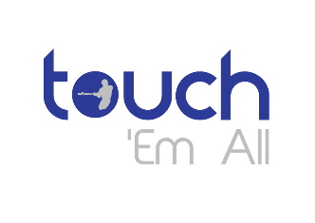
Permission Form and Liability Waiver
Touch Em All Triad, Inc.

I ________________________________________, the parent of _________________________________________ (“my child”), give permission for my child to attend or participate in the following Touch Em All event: _______________________________________________________________________________________________________________________ ,
(Event Description, Location, Time, Date)
under the supervision of the following Touch Em All representative: _________________________________________.

I understand that personal injury can and may occur to my child, and I hereby authorize a Touch Em All official or representative to seek and consent to emergency medical attention for my child as needed; and I further agree to be liable for and to pay all costs incurred in connection with such medical attention.

I hereby release Touch Em All Triad, Inc., its officers, board of directors, agents and volunteers, from any and all liability, claims, demands, causes of action and possible causes of action whatsoever arising out of or related to any loss, damage or injury (including death) that may be sustained by my child while participating in or traveling to and from this event.

The following is all the insurance information, restrictions, allergy and medication information necessary for my child to receive appropriate medical care.
__________________________________________________________________________________________________________________________________________________________________________________________________________________________________________________

I give permission for my child to ride in any vehicle designated by Touch Em All, its representatives and adult volunteers, while participating in and traveling to and from this event.

I agree to accept full responsibility, financially or otherwise, for any damage my child may do to the property of Touch Em All, properties visited on outing, other’s personal property, or vehicles used for transportation.

I agree and consent to all the above stated.

__________________________________________________ __________________________________
(Parent Signature) (Date)

__________________________________________________________________________________________________________________
(Emergency Contact Name and Phone Number, if available.)

Community Standards
In accordance with the policies of Touch Em All Triad, Inc., the following behavior will not be tolerated at any Touch Em All sanctioned or sponsored event. Violation of these standards or being knowingly in the presence of others violating these standards, can and will result in consequences deemed appropriate by the officers and representatives of Touch Em All, including, but not limited to, being sent home immediately at the participant’s expense.
*Possession or use of alcohol, tobacco, or illegal drugs.
*Possession or use of weapons.
*Inappropriate sexual behavior.

___________________________________________________ ____________________________
(Parent Signature) (Date)

___________________________________________________ ____________________________
(Youth Signature) (Date)

