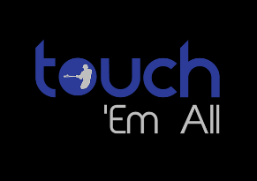
Memo Release (6/5/2020)
Touch ‘Em All COVID-19 Guidelines (as they relate to camps, practices, games and other outdoor activities)
For Players:
- Masks are permissible and encouraged.
- Players should wear their batting gloves as much as possible.
- Bring your own personal water bottle or cooler (labelled with your name). Community coolers will not be provided and drinking from water fountains is discouraged.
- No handshakes, high fives, fist bumps or any other contact with others.
- Maintain 6 feet distance between you and others.
- Do not share food or water. (At camps, we will provide Chick-Fil-A meals that have been safely pre-packaged and boxed individually.)
- Do not share equipment (gloves, bats, helmets, etc.)
- Use hand sanitizer frequently. (This will be provided)
- When you arrive for an event, please remain in your vehicle until the start time.
- Keep your bag, equipment, water, etc. all together and separate from that of others.
- Stay out of dugouts and other close-quarter areas as much as possible. (Only 1 person in the restroom at a time.)
For Coaches, Staff:
- Wear gloves at all times and masks whenever around others.
- Bring your own personal water bottle.
- No handshakes, high fives, fist bumps or any other contact with others
- Do not share food or water.
- Do not use others’ equipment.
- Use hand sanitizer frequently.
- Maintain 6 feet distancing
- Constantly remind players, campers, parents and other staff of the safety protocol.
For Parents:
- Remain outside the field area and away from dugout or area where players are gathered.
- Maintain 6 feet distancing wherever you are watching an event from.
- Please remain in supervision of your child before and after an event.

